Chapter 1׃ Let's Visit Seattle!


Tujuh Pembelajaran:

Setelah mempelajari Bab 1, siswa diharapkan mampu:

- Mensyukuri kesempatan dapat mempelajari bahasa Inggris sebagai bahasa pengantar komunikasi International yang diwujudkan dalam semangat belajar.

2.1 | Menunjukkan perilaku santun dan peduli dalam
 | melaksanakan komunikasi interpersonal dengan guru
 | dan teman.
2.2 | Menunjukkan perilaku jujur, disiplin, percaya diri,
 | dan bertanggung jawab dalam melaksanakan
 | komunikasi transaksional dengan guru dan teman.
2.3 | Menunjukkan perilaku tanggung jawab, peduli,
 | kerjasama, dan cinta damai, dalam melaksanakan
 | komunikasi fungsional.
3.10 | Menganalisis fungsi sosial, struktur teks, dan unsur
 | kebahasaan untuk menyatakan dan menanyakan
 | tentang pengandaian diikuti oleh perintah/saran,
 | sesuai dengan konteks penggunaannya.
4.14 | Menyusun teks lisan dan tulis untuk menyatakan
 | dan menanyakan tentang pengandaian diikuti
 | perintah/saran, dengan memperhatikan fungsi sosial
 | struktur teks, dan unsur kebahasaan yang benar
 | sesuai konteks.


Bahasa Inggris | 1

A. WARMER: PAIRWORK

Discuss with your friends when you come to a new city.

B. OBSERVING AND QUESTIONING

Reading: Read the following text.

Six Things To Do If You Visit Seattle

There are 6 must-have experiences that you should do if you visit Seattle where city and nature come together. If you visit Seattle, arrive with this list in hand and you’ll be off to a foolproof start for exploring the Emerald City’s most unforgettable sights and sounds. If you visit Seattle:

- Feel the fresh air on your face as you sail to Bainbrige Island on a Washington State Ferry. From the ferry you can enjoy the view of the Seattle skyline. You can also stroll around downtown’s galleries, boutiques, coffeehouses and cafes. Seasonal gardens and natural woodlands at the Boedel

Reserve is another option.

Source: wsdot.wa.gov/ferries

Picture 1.1 Bainbridge island
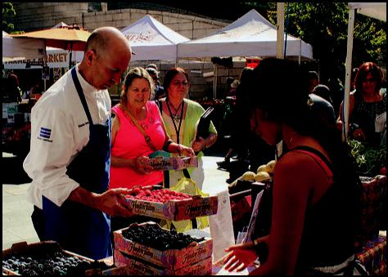

2. Why don’t you tour Pike Place Market’s produce stands and buy something you’ve never tasted. The Pike Place Market is much more than a farmers’ market. Its entire district full

of shopping, attractions and favorite sights. The area is

Source: pikeplacemarket.org

Picture 1.2 Pike Place Market


- Kelas XII SMA/MA/SMK/MAK

festival of sounds, tastes and smells is part of the reason it’s called the ‘soul of Seattle’. Amid all the joyful hubbub, make sure you take time to spot these beloved icons.

Source: visitsanjuans.com
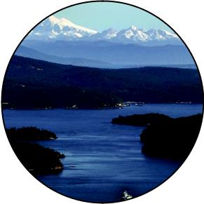
Picture 1.3 San Juan Island

- See exciting and experimental works at Chihuly Garden and Glass. A visit to this site is an opportunity to take full advantage of the location at the Seattle Center, a premier destination for arts, entertainment and leisure activities. Explore the Space
Needle and Pacific Science

Center. Experience Music Project and a variety of cultural activities offered throughout the year.


- Book a night at one of the many cozy B & Bs or resorts available throughout the Sun Juan Islands. Cozy bed and breakfasts are perfect way to enjoy the friendly island culture. Here, you can tour the numerous art galleries in Friday Harbor. You can also enjoy naturalist-guided tours, wildlife spotting, whale watching and storm watching.
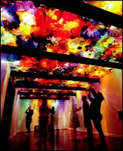

Source: futureofflight.org Picture 1.4 Chihuly Garden

Bahasa Inggris | 3

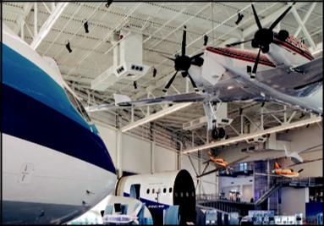

Source: futureofflight.org

Picture 1.5 Boeing factory in Mukilteo

- For a sweet treat, tour

the Theo Chocolate factory in Freemont and learn how their delicious confections are made. This factory has a mission to create change in the Democratic Republic of Congo (DRC) where it has 300,000 square miles of farmable land but only 2% is being farmed due to conflict there. The factory trains 2,000 Congolese farmers to grow high quality cocoa.

- Watch the world’s most sophisticated aircraft be built before your eyes at the Boeing factory in Mukilteo. Explore the dynamics of flight and experience new aviation innovation. Go behind the scenes at Boeing to watch the very same jets you may one day be a passenger on being assembled.
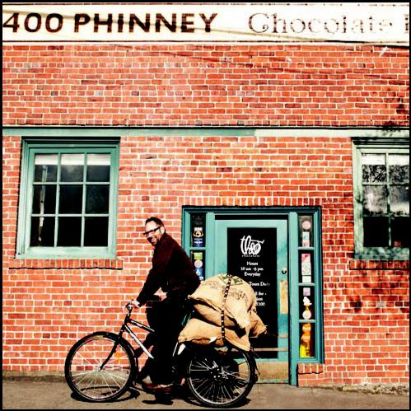

Source: theochocolate.com

Picture 1.6 Theo Chocolate

Vocabulary Builder : Observe the reading text above and write down the synonym of the following words.

f o o l p r o o f ( a d j ) : … … … … … … … … … … … . .

s t r o l l ( v ) : … … … … … … … … … … … . .

p r o d u c e ( n ) : … … … … … … … … … … … . .

a m i d ( p r e p ) : … … … … … … … … … … … . .

- Kelas XII SMA/MA/SMK/MAK

h u b b u b ( n ) : … … … … … … … … … … … . . .

c o z y ( a d j ) : … … … … … … … … … … … . . .

w i l d l i f e ( n ) : … … … … … … … … … … … . . .

l e i s u r e ( n ) : … … … … … … … … … … … . . .

s o p h i s t i c a t e d ( a d j ) : … … … … … … … . .

a v i a t i o n ( n ) : … … … … … … … … … … … . .

a s s e m b l e ( v ) : … … … … … … … … … … … .

t r e a t ( n ) : … … … … … … … … … … … . . . . . . .

Pronunciation Practice:
Listen to your teacher reading these words. Repeat after him/her.

a m i d : / əˈmɪd /
S e a t t l e : / siˈætl /
E m e r a l d : / ˈem ə rəld /
B a i n b r i g e I s l a n d : / ˈbeɪnbrɪdʒ ˈaɪlənd /
s t r o l l a r o u n d : /stroʊl əˈraʊnd /
g a l l e r y : / ˈɡæləri /
b o u t i q u e s : / buːˈtiːk /
c o z y : / ˈ kəʊzi /
c a f e s : /kæˈfeɪ/
n u m e r o u s : / ˈ nuːmərəs /
l e i s u r e : /ˈ liːʒər /

s o p h i s t i c a t e d : /səˈ fɪstɪkeɪtəd /

C. COLLECTING INFORMATION

Practice: Asking and Answering Questions
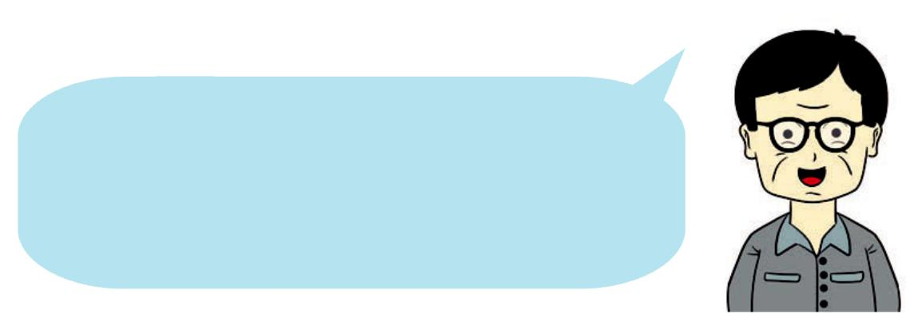

Still related to the reading text above, play the roles of the speakers in the pictures. Complete the blanks with suitable expressions.

Bahasa Inggris | 5

A : What is another name |  | A : What can we do at the
for Seattle? |  | Bloedel Reserve?
B : It is called the Emerald City. |  | B : We can visit seasonal
 |  | gardens and natural
 |  | woodlands.

A : What can we do at the Pike Place Market?

B : We can tour .....................................and............................

A : .............................................................................................

B : Its entire district is full of shopping, attraction and sights.

A : .............................................................................................?

B : The area's festival of sounds, tastes and smells.

A : ....................................Chihuly Garden and Glass?

B : It is a premier destination for arts, entertainment and

favorite sights.

A : ......................................at Chihuly Garden and Glass?

B : The Space Needle and Pacific Science Center.

A : Where...........................?

B : At the Boeing factory

in Mukilteo.

A : ..............................?

B : Explore the dynamics of flights and experience new aviation innovation.

A : ...........................for a

sweet treat?

B : Tour the Theo Chocolate factory in Freemont.

A : ..............................?

B : The mission of the chocolate factory is to create change in the Democratic Republic of Congo (DRC).

- Kelas XII SMA/MA/SMK/MAK

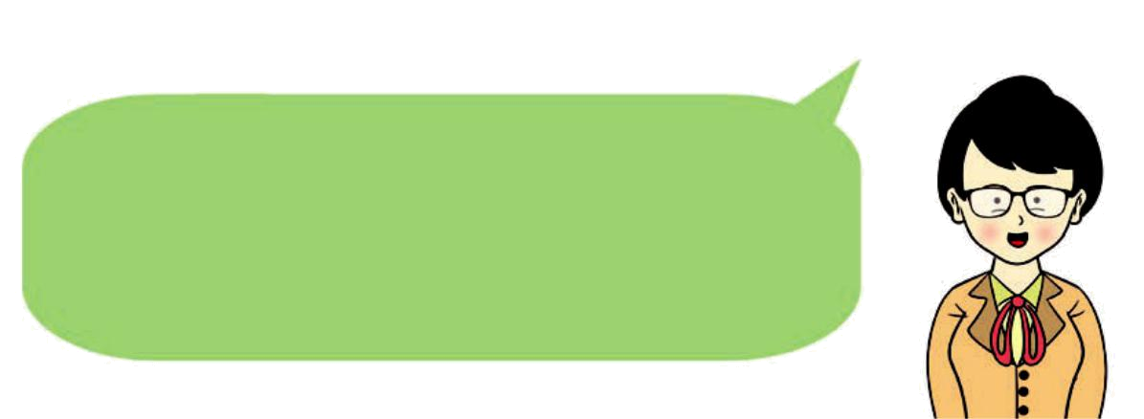

Now, observe the following conversation in which some speakers offer help to others. Identify the expressions of offering. Then perform the dialogue with your friends.

Anita : May I help you?

Fatah : Yes, please. I need a book entitled "Visiting Seattle."

Anita : Sure. We have one copy left. I'll get it for you.

Fatah : Thanks.

Made : We have to submit the report of our visit to Lake Toba tomorrow but I think there are still a lot of problems with the grammar, spelling, and so on.

Hilda : What if I take half of it and I'll edit the rest after I finish this one.

Made : That's very thoughtful of you. Thanks a lot.


Please complete the following sentences

by referring to the reading text above.

Example:

If you visit Seattle, arrive with...............................................

If you visit Seattle, arrive with this list of six must-have experiences.

Bahasa Inggris | 7

- If you visit Seattle, the first thing to do is .................................

.......................................................................................................

.......................................................................................................

- The second thing to do is ..........................................................

......................................................................................................

......................................................................................................

3. The 'Soul of Seattle' is the name for .........................because

.......................................................................................................

.......................................................................................................

4. .......................................................................................................

.........................................................................is the third

instruction to follow if you visit Seattle.

- If I am in the San Juan Islands, I will be able to enjoy ..........

.......................................................................................................

.......................................................................................................

- The fourth instruction to follow is .............................................

.......................................................................................................

.......................................................................................................

- Chihuly Garden and Glass customer service may offer a help to a guest saying ................................................................
.......................................................................................................

- If you were an aircraft factory staff, what would you say to offer help for your visitors. What if ...........................................
.......................................................................................................

- Two instructions to follow at the Boeing factory are ...............

....................and ...........................................................................

- Imagine you are visiting Lake Toba with your classmates. Your friends want to go canoeing but do not know how to do it. What would you say to help them ................................
....................................................................................................

- Kelas XII SMA/MA/SMK/MAK

D. ASSOCIATING


Grammar Review
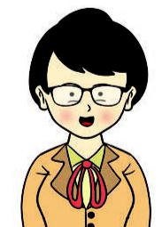

Now, discuss with your friends

‘if’ sentence patterns as appear in the reading text ‘If You Visit Seattle’ above. Write down the patterns in the

space below.

- Sentence 1:

If you visit Seattle, feel the fresh air on your face as you sail to Bainbridge Island on a Washington State Ferry.

Pattern 1:

‘If clause’ + a suggestion.

- Sentence 2:

..................................................................................................

Pattern 2:

..................................................................................................

- Sentence 3:

..................................................................................................

Pattern 3:

..................................................................................................

- Sentence 4:

..................................................................................................

Pattern 4:

..................................................................................................

Bahasa Inggris | 9

- Sentence 5:

..................................................................................................

Pattern 5:

..................................................................................................

ReAD the following conversation

Father : Exam is around the corner. It's about time to go back to your study.
Son : Okay, Dad.

Father : If you want to pass the exam, you have to study harder.
Son : Thanks, Dad.

Dela : Where can I get inexpensive price for good quality shoes?
Emi : If you want a good price, why don't you go to the factory outlet?

Mr.Lukman : If you want to be the chair of OSIS, offer a good program to improve the school environment.
Nyoman : Sure, I will.

Mom : If you don't put some cherries on it, your cake will look pale and dull.
Etty : Yes, you're right. A cherry or two will help the appearance.

- Kelas XII SMA/MA/SMK/MAK

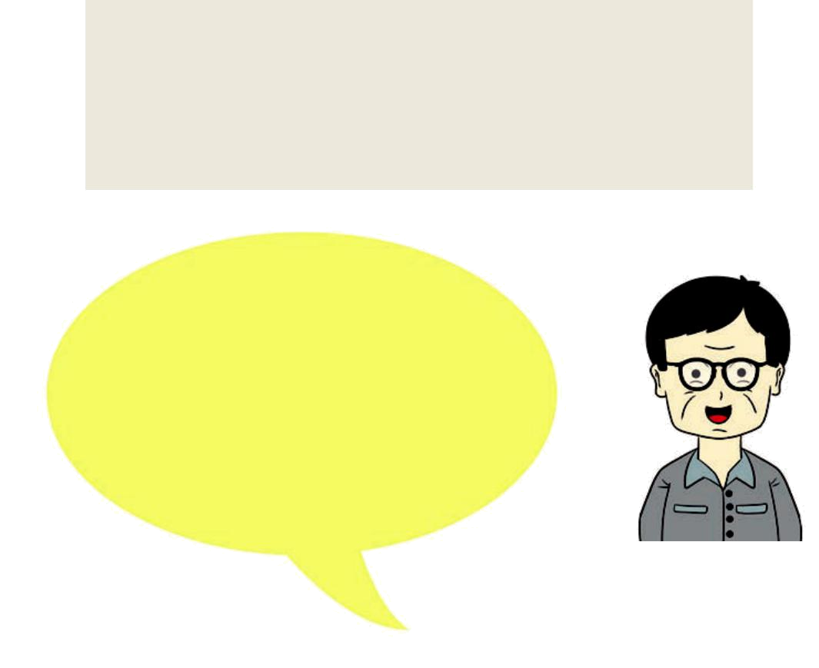

Joko : If I am elected president, I will waive taxes for poor people.
Edwin : I wish you all the best.

Complete the following blanks

by looking at the information in

the conversations above. Number 1

is given to you as the example.

1. An example of ‘if clause’ + a reminder is:

If you want to pass the exam, you have to study harder.

- An example of 'if clause' + a suggestion is:

.......................................................................................................

.......................................................................................................

- An example of 'if clause' + a general truth is:

.....................................................................................................

......................................................................................................

- An example of 'if clause' + an imperative is:

......................................................................................................

......................................................................................................

- An example of 'if clause' to show a dream is:

......................................................................................................

......................................................................................................

Bahasa Inggris | 11

F. Associating


Now, identify the ‘if clauses’ and

expressions of ‘offering help’ in the

reading text that you brought from

home. Write them down in the

following spaces.
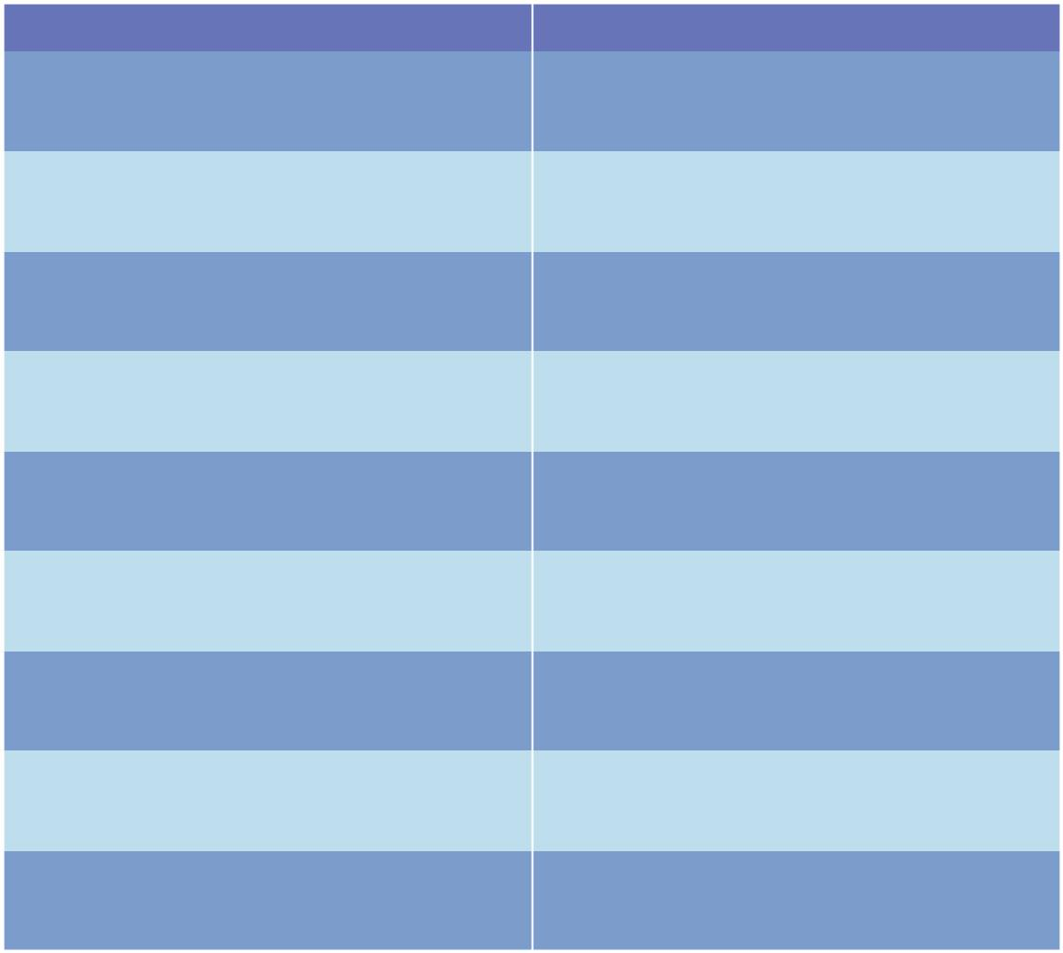

If Clause | Offering Help


Now, exchange your work with your peers.

- Kelas XII SMA/MA/SMK/MAK

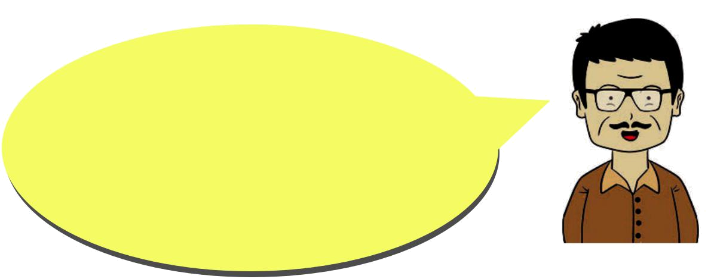

Remember your visit to an interesting place sometime ago. Your friends plan

to visit that place. Give suggestions to your friends. To prepare yourself, make a note. Look at the following example.


Example:

If you visit Seattle,

- Sail to Bainbrige Island on a Washington State Ferry.

- Tour Pike Place Market.

- Book a night at Sun Juan Islands.

- Visit Chihuly Garden and Glass.

- Watch the aircraft being built at the Boeing factory.

- Tour Theo Chocolate factory in Freemont.

Now, you're ready to give your tips to your friends. Don't

forget to include ‘if clause’ + imperative/suggestion in your tips.

Please also offer a help if your friends need more information.

Bahasa Inggris | 13

R E F L E C T I O N
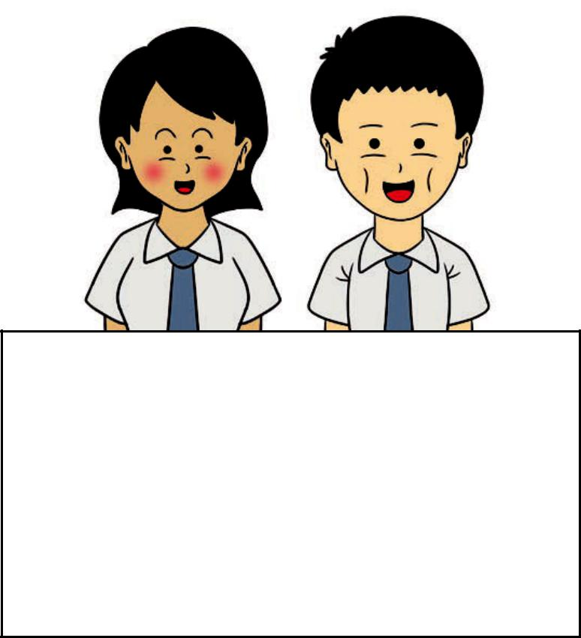

- Do you know how to tell your friends about visiting a place using 'if' clause followed by imperatives/suggestions?
- Do you know how to write texts about visiting a place using 'if' clause followed by imperatives/suggestions?


- Kelas XII SMA/MA/SMK/MAK

